Fitting factor analysis of the Doreme I and II basic pattern system on size m blouses

Fira Dia Ayu Candra ¹, Hapsari Kusumawardani ^{2, *}, Sri Eko Puji Rahayu ³
^{1,2,3} Universitas Negeri Malang, Indonesia
Email: hapsari.kusumawardani.ft@um.ac.id*
*Corresponding author

ABSTRACT
The Doreme I and II pattern system is not quite popular. This research aimed to observe the fitting factor on women’s blouses using the Doreme I and II basic pattern system on a medium size blouse. This study used the descriptive method and quantitative approach. Instruments such as questionnaires containing 14 indicators of fitting factor were used to analyze the fit with percentage analysis. Based on the Doreme I pattern assessment on an M-size blouse, the fitting factor result was a poor fit. The results were 54.76% in the fit category, 28.57% in the poor fit category, and 16.678% in the not fit category. Meanwhile, the Doreme II pattern assessment on the M-size blouse obtained a fitting factor in the fit category. The results were 71.42% in the fit category, 19.04% in the poor fit category, and 11.9% in the not fit category. Also, according to the analysis, the Doreme II pattern had a precise position in several parts, while in Doreme I, due to the various additional numbers causing the dart to cross the bust circumference line. Thus, the bust circumference line must be adjusted to avoid a higher dart position.
Keywords: Fitting factor, blouse, the doreme I and II system
Article history
Received:  22 Maret 2024 | Revised:  25 Mei 2024 | Accepted:  26 Mei 2024 | Published:  15 Juni 2024
Citation (IEEE Style): F. D. A. Candra, H. Kusumawardani, S. E. P. Rahayu, “Fitting factor analysis of the doreme i and ii basic pattern system on size m blouses,” MERAKI: Journal of Creative Industries, vol. 01, no. 2, pp. 01-11, Jun. 2024.
INTRODUCTION
Comfort in fashion depends on the correct basic pattern, whether the seams on the shoulders, body/torso, and waist are in the correct place. A basic clothing pattern is based on a person’s body size and used as a mold to make clothing based on the desired model [1]. According to [2], basic patterns are excerpts from the original human form or patterns that have not been modified. These basic patterns consist of the upper body part, from shoulder to waist, commonly called the front and back body. Various basic patterns are body/torso patterns, skirt patterns, basic sleeve patterns, basic pants patterns, and more.
Various pattern-making systems, such as the Doreme pattern, are taught in training centers. The Doreme pattern is a basic fashion pattern that is practical and easy to apply. The pattern making is started by making the back part first with predetermined addition in several parts. This basic pattern consists of the Doreme I and II; the difference lies in the additional formula for those several parts. Basic pattern-making must be developed to find a more practical system and comfortable usage, hence, easy to apply.
Clothing is a basic need for humans to wear as a protection and appearance aesthetic. Women usually wear blouses. A blouse is a garment that covers the upper body up to below the waist [3]. Another opinion states that blouses are loose model shirts worn by women and children, covering the body from the neck or shoulders to the waistline with or without collar and sleeves, tucked in or not with skirt or trousers [4]. Blouses making requires a pattern as a mold following the predetermined size.
Based on a statement that the Doreme pattern is an essential fashion pattern that is practical and easy to apply, the Department of Fashion Education implemented it in the classroom. Then, this research aimed to find the fitting factor of the blouse using the Doreme I and II basic patterns conducted by Fashion Education Major undergraduate students at the State University of Malang, Indonesia. Hopefully, it recommended a better fashion pattern easy for students.

The Doreme Pattern
Human has different body sizes. Thus, one must understand individual body shapes in making or picking clothes. Apart from that, clothing suitability is also affected by the pattern, and the desired clothing is easy to make using a pattern that suits the size. Sizing is obtained by measuring the user’s body shape or using standard sizing, such as S, M, L, and XL.

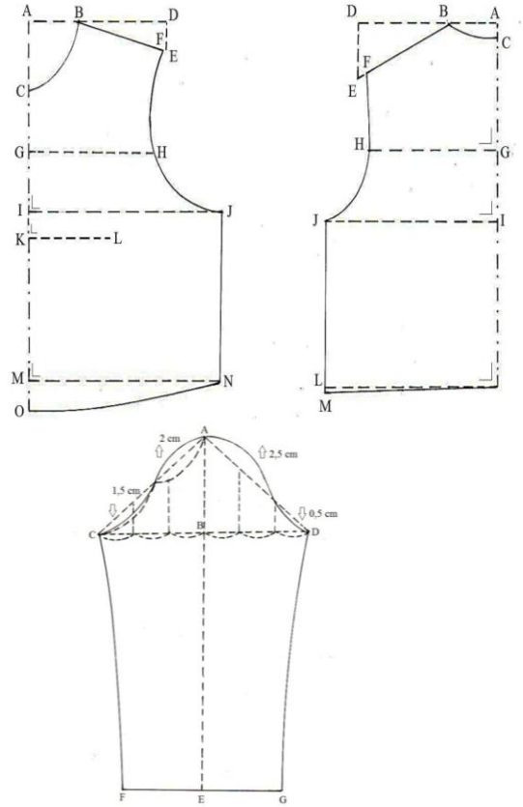

Figure 1. Basic Doreme Torso and Sleeve Patterns Source: Garment Team (2011:21)
The Doreme is a basic pattern made through the flat pattern. Initially, this pattern originated in France, then entered Japan and was developed for the first time by Sugino Yoshiko, and this system is then more known to originate from Japan [5]. Doreme pattern has two systems: Doreme I and II, and the two could be differentiated through their formulas. This pattern has yet to be popular compared to Maynekke, Dankart, Bunka, or So’en. The Doreme I goes through 12 steps for the back pattern and 15 for the front.
Meanwhile, the Doreme II goes through 13 steps for the back pattern and 14 for the front. The pattern shapes are identical except for the additional numbers in different parts. Below are the Doreme pattern shapes. Figure 1 is the Doreme pattern shapes.
The fitting factor on both Doreme is found in the formula to draw the pattern. Besides, the difference between both patterns is in the finished form, in which in the Doreme I, the front part would be larger than the back part, and in the Doreme II, the front and back parts have a similar size. The size difference covers:
- The formula to determine the neck circumference point at the end of the neck in the Doreme I back pattern is $\frac{neck circumference + 0.5 cm}{6}$ while in the Doreme II is $\frac{neck circumference + 0.7 cm}{6}$
- The formula to determine the neck circumference point at the center back in Doreme I is subtracted by 1.8 cm, while in Doreme II is 2 cm.
- The formula to determine the shoulder point at the center back in Doreme I is subtracted by 6 cm, while in Doreme II is 5 cm.
- The formula to determine the backline point at the center back in the Doreme I is $\frac{backline}{2}$ + 1 cm while in the Doreme II is $\frac{backline}{2}$ + 2 cm.
- The formula to determine the bust circumference point at the center back in the Doremi I is $\frac{bust circumference + 8 cm}{2}-1,5 cm$ while in the Doreme II is $\frac{bust circumference + 8 cm}{2}+8 cm$ with no subtraction.
- The formula to determine the neck circumference point at the end of the neckline in the front pattern Doreme I is $\frac{neck circumference + 0.5 cm}{6}$ while in the Doreme II is $\frac{neck circumference + 0.7 cm}{6}$
- The formula to determine the neck circumference point at the end of the shoulder seam in the front pattern Doreme I must be subtracted by 3.4 cm, while in the Doreme II is 4 cm.
- The formula to determine the bust circumference point at the front Doreme pattern is $\frac{bust circumference + 8 cm}{2}+1,5 cm$ while in the Doreme II is $\frac{bust circumference + 8 cm}{2}$ without any addition.

The produced garment using the Doreme basic patterns has a seam between the inner sleeve line and a side line, while in typical women's garment making, the seam moves 1 cm from the side line. This method is practical because some points do not require measurement since they are all predetermined, such as the neck circumference point on the back pattern, neck circumference point on the front pattern, shoulder point, and waistline point.

Fitting Factor
Clothing is not only called visually appeasing from design, color, or pattern but also through its suitability with the wearer’s body. A suitable garment following the wearer’s body makes it feel right, not too loose or tight. Several factors, such as the correct measurement, pattern system, and sewing technique, influence the suitability.
A fitting garment must fulfill several criteria. McRoberts described 13 criteria [6]. These criteria are:
- The vertical fiber is perpendicular.
- Seams on the side line are straight and perpendicular.
- The bust, back, waist, and hip lines are parallel horizontally.
- The hemlines are flat and parallel.
- Clothes hang freely without being pulled or twisted/wavy
- Overall garment appearance is neat and smooth (due to pressing).
- The end of the waist dart is 1 inch (2.5 cm) below the apex.
- There are no wrinkled surfaces, either vertically or horizontally.
- The mid-back is flat against the back without being stretched or bulged.
- The area between the neckline and waistline (front length) is correct.
- The area between the waistline and the hip line is correct.
- Measurement fit (not too loose or tight) in the bust, waist, and hip lines.
- Position fit in the bust, waist, hip, neck, and base sleeve lines.

A fitting garment is a garment with the correct fitting factor and does not shift. A blouse with a suitable wearer’s body could be a reference for pattern line location. The fitting factor is a location or point on a garment that determines whether the pattern system suits the body shape that wears it [7]. The basic fitting points of a garment consist of (1) neckline, (2) armhole, (3) shoulder line, (4) dart position, (5) bust circumference, (6) waist circumference, and (7) back pattern. Each position of the fitting factor has defined position accuracy criteria. A garment’s fitting point can be seen by wearing the finished garment, made from a specific pattern on the body that has been measured.

Women Blouse
Clothing according to gender is divided into men’s and women’s clothing [20]. Women’s clothing consists of various types: blouses, shirts, skirts, pants, dresses, jackets, and others [21]. Women often wear a blouse, a garment that covers the upper body in a loose style with length up to the waist so that when worn, it hangs over the wearer’s body [22].

METHOD
This research used a descriptive method with a quantitative approach [23]. The respondents were the Class of 2015 Fashion Education Major undergraduate students State University of Malang, Indonesia. The data collection technique used sampling purposive to determine a trial sample with specific consideration and was chosen because the picked students were M-sized standard type. The samples were three students with M-size body types. The validity test was utilized to obtain data with judgment experts from Fashion Education lecturers who mastered women's blouses. The instruments were observation forms for all three panelists and consisted of two pattern systems: Doreme I and II. Data was collected through a questionnaire. The data was then analyzed using percentage analysis in these steps: (1) scoring, (2) tabulating, (3) statistical test, (4) data interpretation, using the formula below:

P=f/n x 100% [8]
Description:
P = comfort factor percentage
f = fit, less fit, and unfit frequencies
n = overall total criteria

Another opinion about the blouse is clothing that covers the upper body below the waist. Blouses are worn with skirts or trousers. Based on the above statements, it can be concluded that a blouse is a woman’s top dress worn on the upper body with length up to the waist or more, has sleeves or sleeves and a collar, and can be paired with skirts or pants by putting tucking in or not.
Clothing experiences rapid development along with modernization. Fashion creators are compelled to create various types of clothing, especially blouses. Blouses can be divided into several types. The style and details of the blouse follow the current fashion, which can be fitted, straight and boxy, or loose and baggy [9].
According to Pratiwi in Aminah [10], broadly speaking, blouses are divided into two (a) loose blouses and (b) body-fitting blouses. Loose blouses are worn without tucking, complete with collars, sleeves, pockets, or buttons, although some are collarless, sleeveless, or pocketless, and some with her waist or harmless. Body-fitting blouses are tucked in, while loose-fitting blouses are primarily with or without a collar, sleeves, and pockets.
Blouses range from small, medium, large to extra-large. Medium size (M) is close to an ideal woman’s body [11]. Thus, M's body size is neither too fat nor too thin, making it easier to determine the fitting factor.

RESULTS
This research aimed to find the fitting factor of the blouse using the Doreme I and II basic patterns in size M and amounted to 14 criteria. Based on the panelists’ calculation based on the above 14 criteria, the following results are obtained:
Panelists’ observations on the blouse fitting factor using the Doreme I system resulted in 54.76% in the fit category, 28.57% in the poor fit category, and 16.67% in the not fit category (Figure 2).
Panelists’ observations on the blouse fitting factor using the Doreme II system resulted in 71.42% in the fit category, 19.04% in the poor fit category, and 11.9% in the not fit category (Figure 3).
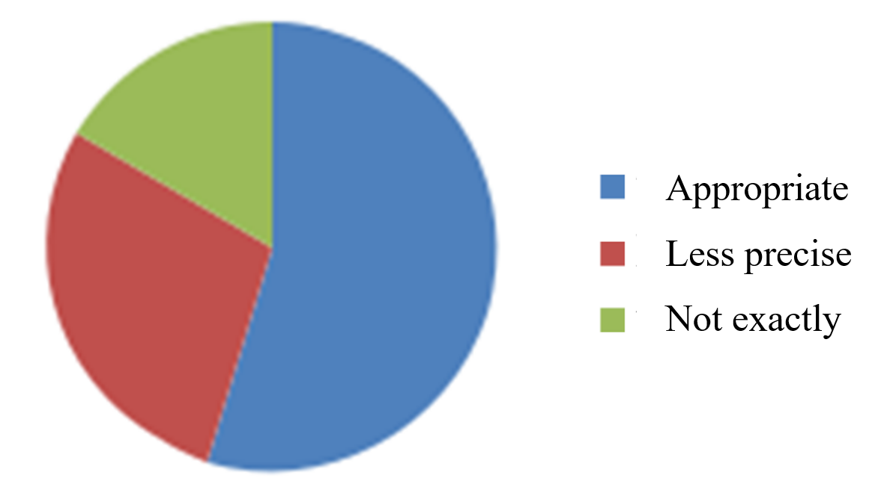
Figure 2. Observation Result Percentages of Fitting Factor Using the Doreme I in M-size Blouses

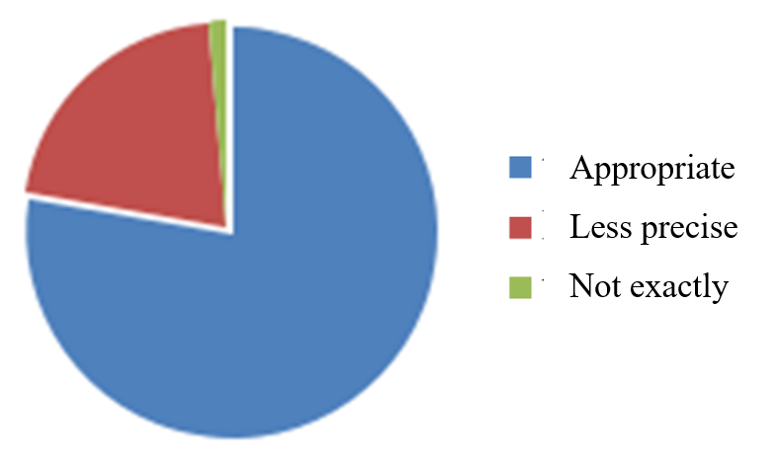
Figure 3. Observation Result Percentages of Fitting Factor Using the Doreme II in M-size Blouses
Fitting Factor Analysis Using the Doreme I and II Basic Pattern System on Size M Blouses

The fitting factor is a point on clothing determining whether the utilized pattern suits the wearer’s body [12]. The fitting factor of a garment can be seen by wearing the finished garment. There were 14 criteria to determine the fitting factor, as observed by the panelists in this research. They were: (1) bust circumference fit, (2) waistline fit, (3) hip line fit, (4) side line fit, (5) front width fit, (6) back width fit, (7) front length fit, (8) back length fit, (9) shoulder length fit, (10) neckline fit, (11) front dart fit, (12) back dart fit, (13) armhole fit, and (14) sleeve fit.
Based on the above results, generally, the Doreme I and II in M-size Blouses are appropriate ways to learn basic patterns for Fashion Education Major undergraduate students at the State University of Malang. This happened because these patterns are easy to understand and implemented by students.

DISCUSSION
To understand the results of this study easily, researchers constructed a discussion consisting of 14 indicators of fitting factors using the Doreme I and II in M-size Blouses: bust circumference position, waistline position, hip line position, sideline position, front width position, back width position, front length position, back length position, shoulder line position, neckline position, front dart position, back dart position, armhole position, and sleeve line position. The explanation is as follows.

Bust Circumference Position
The bust circumference fit is one of the determinants of whether or not clothes can be worn, and errors in that affect other measurements in pattern making. As stated by [13], the clothing fit of dresses sewn for women with figure problems depends mainly on the accuracy of the measurements used for drafting the basic block for the dresses [13]. The Doreme I pattern-making system has different additions to the Doreme II pattern, affecting the parts’ position. In the Doreme I formula, the bust circumference (I-J) was added by 8 cm and another of 1.5 cm, while the Doreme II pattern did not; hence, it had a larger pattern. Additionally, the front neckline (A-C) was added 1.8 cm, while the Doreme II pattern was added 2 cm. Bust circumference is measured through the underarm circle to the back and front, top of the chest and right at the largest circumference [14]. The difference in additional numbers made the Doreme I pattern dart past the bust circumference.

Waistline Position
The waist circumference position in the Doreme Pattern measurement is the same as in other pattern measurement systems, measuring around the waist right at the waistline. According to [15], the correct waist circumference position is if it looks even around the waistline on the front, sides, and back with no stretch or bulge anywhere. The results of this study indicated that the waist circumference position in both Doreme I and II patterns was included in the fit category because it was located precisely flat around the waistline.

Hip Line Position
The correct hip circumference is if it lies flat around the largest pelvis and is added space by 2 cm, with no fabric stretch and bulging from front to back. Based on the results, the hip line position of the Doreme I and II Patterns had the same value and were included in the fit category, and each length shirt addition was right at the hip circumference position.

Side Line Position
Based on the results, the side line position (IM-JN) in the Doreme I and II pattern had the same measurement system. However, the method caused the position of the Doreme II pattern side line to shift slightly, although it did not affect the comfort. In the Doreme I pattern, the side line position was more precise than in the Doreme II pattern because the Doreme I front pattern was larger than the back pattern. The correct side line is on the side line of the shirt, measured from under the armhole to the waist [15], with no upward or downward stretch and no bias stretch forward or backwards. The results showed that the side line position was in the fit category because it was straight from the armpits to the waist.

Front Width Position
This correct position is if the front width (G-H) is horizontal, straight 7 cm below the neck circumference point in the front center and the width line is not above or below the curved line of the right sleeve line to the left sleeve. The calculation results showed that the front width position was in the fit category because of the above factor.

Back Width Position
To determine the formula for the size of the back width (G-H) between the Doreme I and II patterns, use the same technique: from the midpoint of the back of the neck down along the shoulder width. The assessment results showed that the back width position was in the fit category; it was horizontal and straight, not located too above or below the line of the right arm to the left arm. Aldrich [15] states that the back width fits if the back width line is ± 15 cm vertical below the collarbone in the back center and if it is not located too above or below the line of the right arm to the left arm.

Front Length Position
Determining the front length (C-M) in the Doreme I and II patterns has its technique through measuring half back length added with 1.5 cm and the chest circumference plus 3 cm. The line was straight and parallel to the highest shoulder point. The assessment results showed that the front length position was in the fit category since it was located right in the front center, from the neckline to the waist, and did not shift to the right or left. The result confirmed what Aldrich [15] said, the correct front length position occurred if the front length line is located right in the front center starting from the neck to the waist and not shifting to the right or left and not located too high or low than the neckline to the waist.

Back Length Position
The back length line fits if it goes straight down in the back center, from the collar bone to the waist [16]. The line should not bulge and be neat when flattened with both hands. The assessment results showed that the back length position (C-K) was in the fit category because it was located right in the back center, down from the neck to the waist and did not shift.

Shoulder Line Position
The Doreme I and II differ in determining the shoulder line (B-D). In the Doreme I front pattern, the shoulder point is subtracted by 3.5 cm and the back by 6 cm, while for the Doreme II front pattern, the shoulder point is subtracted by 4 cm at the front and on the back by 5 cm. The 2.5 cm difference causes the back shoulder position of the back pattern in the Doreme I to be stretched up. To create a tiny dropped shoulder, extend the shoulder line by 2cm both front and back [17].
Soekarno (2002) states that the shoulder line fits if it lies horizontally from the neckline to the lowest part of the shoulder (base of the arm). The shoulder line should not be stretched. For the Doreme II pattern, the results showed that the position was in the fit category since the back and front positions difference was only 1 cm; hence the position was correct in place and was not stretched from the shoulder line.

Neckline Position
The neckline (A-B) differed in numbers in the Doreme I and II patterns. The 0.2 difference in the hem line to the shoulder and front center calculations affected the neck circumference looseness. The assessment results showed that the neckline position was in the fit category since there was no stretch from the fabric around the neckline. As stated by Prahastuti [7], the accurate neckline has no stretch in the fabric. The numbers that differ in the two patterns indicated no effect on the neckline since it was small.

Front Dart Position
A dart is a folded wedge of fabric that confines unneeded fullness in certain areas to shape a garment to body curves [18]. A dart is a line to form the body and should not exceed the apex. Based on the panelists’ assessment, the front dart position on the Doreme pattern was in the not fit category because the front dart rose higher than the apex and crossed the bust circumference line. Dart points should stay close to the bust apex. The front dart area fit is done by observing the accuracy in following the bust line, the accuracy of the bust area, and the dart line appearance. The dart appearance fits if the cup pleats are located approximately 2.5 cm before the apex and pointing to it, following the bust flexibly, not too pointy, with no bulge or stretch.

Back Dart Position
The results showed that the back dart position was in the fit category because it was 2.5 cm below the bust line with no bulge or stretch. The correct dart with cup pleats should be 2.5 cm below the bust line. As stated by [19], the common problem in darts is when it does not match the actual position. The back dart position generally has two lanes on the right and left sides of the back center. Dart shapes clothes follow the back curves to look neater when worn.

Armhole Position
The correct armhole position is when the sleeve line is flat around the armholes and the sleeves do not stretch or pull around. In the Doreme system, the side line is sewn with the sleeve line, just as in sewing a simple shirt or blouse. In women’s clothing, usually, the sleeve line has an excess, thus leaving 1 cm from the bust line. In the Doreme I pattern, the armhole position was in the poor fit category, whereas the Doreme II pattern was in the fit category. The difference was due to the different formulas in determining the armhole. The Doreme I only has 1 cm, while the Doreme II added 2 cm. Thus, it certainly affects the sleeve line.

Sleeve Line Position
The sleeve line position is correct if it is located straight in the sleeve line, not too forward or backward, and does not look twisted when worn. The results showed that its position was in the not fit category since it seemed to shift from the inner sleeve line. This result happened because of the incorrect sewing. As stated by Halimka [12], the poor fit positions are on the bust line and armholes, and the others are appropriate positions. Sewing the sleeve part requires technique and perseverance.

CONCLUSION
This paper reached some conclusions: For the blouse fitting factor using the Doreme, I acquired nine fit categories: waistline, hipline, sideline, front width, back width, front length, back length, neckline, and back dart; (2) The blouse fitting factor using the Doreme II acquired 11 fit categories: bust circumference, waistline, hip line, front width, back width, front length, back length, shoulder line, armhole, neckline, and back dart; (3) In both systems, the bust line was too upward compared to the actual bust line, thus resulting in front darts that crossed the apex. Meanwhile, several suggestions for future research are the Doreme I and II system utilization must consider the bust circumference so that the front darts do not appear higher than the apex and it would be better to use a dress form as the research model because no human body is the same even if they are in the same body size.

ACKNOWLEDGMENT
Researchers would like to thank the Department of Culinary and Fashion Education and the Faculty of Engineering, State University of Malang, for funding the 2023 international conference and convention research.

REFERENCES
- H. Kusumawardani, Konstruksi Pola dan Pecah Model. Diktat perkuliahan. Fakultas Teknik UM: Malang, 2017.
- Pratiwi dalam Vermayanti, (2013), “Hubungan kemampuan analisis desain, mengukur tubuh dan membuat pola dasar dengan hasil pecah pola busana kerja wanita di SMK Negeri 6 Surabaya”, Jurnal Unesa Edisi Yudisium. Vol. 2, pp. 100-104, Feb 2013.
- Suryawati, dkk., Membuat Pola. Remaja Rosda Karya: Bandung, 2011.
- Dictionary.com. Blouse Definition & Meaning. [Online], March 25, 2023. Available: https://www.dictionary.com› browse › blouse. Diakses
- Tim Garmen, Teknik Membuat Pola Dasar. Balai Besar Kerajinan dan Batik: Yogyakarta, 2011.
- L. B. McRoberts, “Petite women: Fit and body shape analysis” (2005). LSU Master’s. Theses. 2370. [Online], April 20, 2023. Available: https://digitalcommons.lsu.edu/gradschool_the ses/2370
- E. Prahastuti, “Aplikasi pola dasar pakaian sistem charmant dan dankaertz pada berbagai bentuk tubuh wanita”, Jurnal Teknologi Industri Boga dan Busana. Vol. 3, pp. 23-29, Maret 2012.
- Fitinline, Perbedaan antara blus dan kemeja. [Online], March 20, 2023. Available: https://fitinline.com/article
- G. Poespo, Pesona Busana Pengantin Barat. Kanisius: Yogyakarta, 2006.
- D. Pratiwi, dkk., Pola Dasar dan Pecah Pola Busana. Kanisius: Yogyakarta, 2001.
- I. Fazrul, Ukuran Baju Wanita Dewasa Indonesia Dilengkapi Tabel. Cari Tahu Ukuran Bajumu, Yuk!. [Online], March 23, 2023. Available: https://berita.99.co/ukuran-baju-wanita-dewasa/
- V. Halimka, “Analisis titik pas (fitting factor) blus pas badan menggunakan sistem pola winifred aldrich pada bentuk tubuh wanita pendek kurus”, Jurnal Inovasi Teknik dan Edukasi Teknologi. Vol. 1, pp. 329-343, 2021.
- E. Patience N and B. E. Nwamaka N, “Development of dress patterns for women with figure flaws in Anambra State”, International Journal of Vocational and Technical Education Research. Vol.5, pp. 1-7, April 2019.
- W. Jiati, Analisa Titik Pas Kebaya Sistem Pola So-En, Meyneke, Dan Boho Menggunakan Bahan Brokat Pada Bentuk Tubuh Wanita Ukuran M (Medium). Skripsi tidak diterbitkan. FT UM: Malang, 2016.
- W. Aldrich, Metric Pattern Cutting for Menswear. United Kingdom, 2011.
- Soekarno, Buku Penuntun Membuat Pola Tingkat Dasar. PT. Gramedia Pustaka Utama: Jakarta, 2002.
- The Shapes of Fabric, The Shapes of Fabric Creative Side of Patternmaking. [Online], Jun 21, 2022. Available: https://www.theshapesoffabric.com
- J. P. D. Nugroho and E. Z. Khayati, “Pengaruh bentuk kupnat terhadap pas-suai blus Wanita: The Influence of Dart Shape on Woman’s Blouse Fit,” Jurnal Fesyen: Pendidikan dan Teknologi. Vol. 9, pp. 1-6, 2020.
- Irmayanti, “Analisis perbedaan fitting factor antara pola. sonny dan pola praktis pada jas,” Jurnal Mekom, Vol.4, pp. 92-103, 2017.
- M. A. Özdil, “The effect of clothing as a marker on identity,” Motif Akademi Halkbilimi Dergisi, Vol. 14, pp. 117-130, 2021.
- S. Heti, H. Julavits and L. Shapton, Women in clothes. Penguin, 2014.
- S. Woodward, Why women wear what they wear. Berg, 2007.
- R. Aggarwal and P. Ranganathan, “Study designs: Part 2 - Descriptive studies,” Perspectives in Clinical Research, Vol. 10, pp. 34–36, 2019.

